**Project Design document**

**Introduction**

The project aims to evaluate by different machine learning methods, if a person might have diabetes based on his medical characteristics.

**Scope**

In the project I will work on a database from Kaggle that contains medical information about approximately 800 different patients, with and without Diabetes. The data contains several relevant features, such as: blood pressure, glucose, BMI, etc. I will use a variety of machine learning models to predict the outcome, examine the combination between them, and compare between them. The project will also include visualizations in relevant project phases.

**Software Design Description**

**General Flow**

A user can insert medical data for a new patient, with the characteristics included in the model, and receive an evaluation if the patient might have diabetes or not.

**Software Architecture - Data Handling**

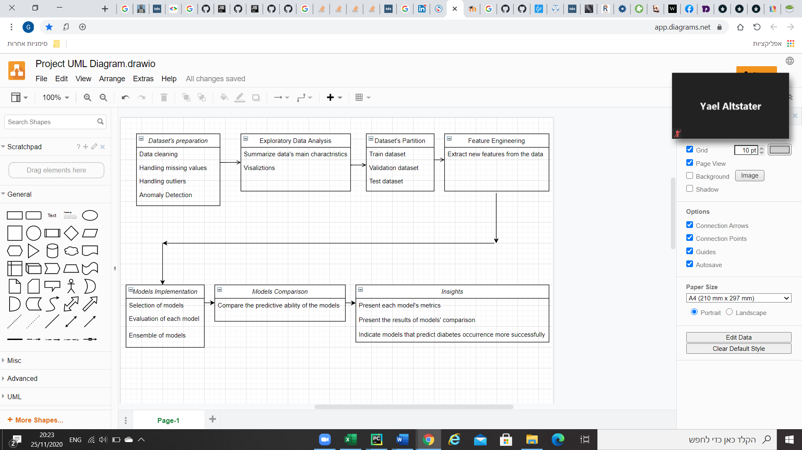

**Tests**

Unit test and integration tests will be included in the project